|  |  |  |  |
| --- | --- | --- | --- |
| **Procedure** | |  | |
| Work at height – Skagerak Kraft | | | |
| Document owner | Ingrid Haug |  |  |
| Auditor | Erlend Kaarstad | Approval date | 26.04.2023 |

# Purpose

The purpose of this procedure is to ensure that all work at height and over water is carried out in a safe manner and in accordance with applicable laws and regulations.

# Scope

The instructions apply to work carried out more than 2 m above ground/floor level where there is a risk of falling to a lower level, such as work in towers, pipe trenches and dams and on ladders, hoists, scaffolding etc. The instructions also apply to work outside permanent railings where there is a risk of falling into water. The requirements apply to all Skagerak Kraft’s operations.

# responsibility

* The HSE Manager at Skagerak Kraft is responsible for ensuring that this document is approved, implemented and maintained.
* Line management are responsible for ensuring that the requirements are known and complied with within their area of responsibility/unit.
* Each employee must have the necessary personal protective equipment, be provided with information and training in its use, and wear it as described in this document. If the personal protective equipment becomes damaged, it is each user’s responsibility to ensure that it is repaired in accordance with regulations or replaced.

# description of work

## Work at height in general

Work at height must be carried out in a safe manner and under appropriate ergonomic conditions from a suitable surface. Collective protective measures must be prioritised ahead of personal protective measures.

## Training

Before using fall-arrest equipment, personnel must receive the necessary training, which must be documented.

## Fall-arrest equipment

All fall-arrest equipment must be CE marked. The equipment must be used and maintained in line with the manufacturer’s specifications. All equipment must be appropriately labelled showing the date of the last certification/inspection.

## Execution

Before the work starts, a JSA must always be carried out, including an assessment of anchorage points and live parts and a rescue plan.

When working at height, at least two people must be present, and approved fall-arrest equipment must be used. Before starting work, each person must perform a buddy check of their colleague’s safety equipment.

An exception to the requirement of having two people present and performing a buddy check applies when using a hoist (see section 4.5) or a ladder (see section 4.6).

The area below where work at height is to be carried out must be cordoned off. If cordoning is not considered appropriate protection, other compensatory measures must be specified in the JSA.

When working at multiple height levels or for work that also requires staying within a cordoned-off area on the ground, the JSA must state what further risk-mitigation measures are to be implemented.

When working at height, tools must be secured. If there is a risk of other objects falling, additional safety measures must be considered. Below is a selection of safety measures for securing tools we use in our facilities.

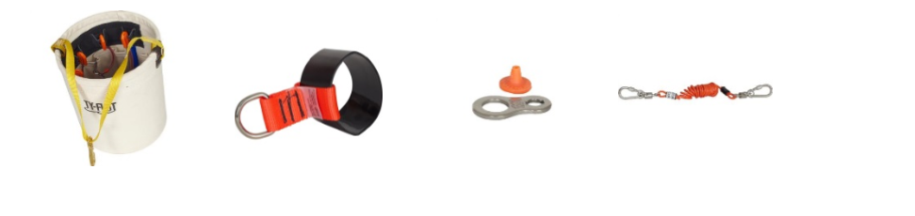

## Work on a hoist

When using a hoist, the fall-arrest harness and lifeline must always be available in the basket.

Personnel who are to use a hoist must have received training in the following:

* using a hoist
* using fall-arrest equipment
* emergency evacuation

Training must be documented in the company’s internal control systems.

When hiring a hoist, it must always be ensured that it is supplied with a safety attachment for emergency evacuation.

## Work on ladders

Ladders must only be used for access. Ladders can exceptionally be used as a work platform for carrying out work at height when it is not appropriate to use other, safer work equipment because the risk is small and the ladder is only used for a short period of time. Freestanding ladders taller than 6 m must not be used. Freestanding combi ladders must not be used at heights over 4 m. In such cases, a JSA must always be prepared. Note the following:

* Ensure the correct angle to the wall/structure (≈ 70°).
* Ladders with adjustable legs should normally be used.
* Ladders must only be used for access and short-term work.
* Ladders with wheels must not be used.
* Ladders must be placed so that they stand stably.
* Ladders must be placed on level ground. Using loose items under the ladder legs to level the ladder is not permitted.
* Ladders must be secured to prevent sliding or tipping in any direction.
* Ladders used repeatedly for access must always be secured at the top.
* Ladders used for access to roofs or similar must project at least 1 m above.

## Work on scaffolding

### General

Scaffolding must be erected properly. It must be constructed from approved parts not showing deformations or excessive wear. Scaffolding must be clearly labelled with the name and owner, scaffolder, employer (user), and where relevant the hire supplier and permitted loads. It must be checked regularly, appropriate to the conditions. The employer must ensure that employees working on scaffolding receive training and practice in the use of relevant fall-arrest equipment during the erection, dismantling and alteration of scaffolding structures, including the use of personal protective equipment (fall-arrest equipment). Training in accordance with internal instructions must be documented in the company’s internal control systems.

The erection of scaffolding over a height of 9 m must be contracted to a qualified external company.

### Scaffolding over 2 m high

Work from scaffolding over 2 m must be performed by employees with the necessary theoretical and practical training. In order for the employer to be able to assign an employee to work independently on the erection, dismantling, alteration and inspection of scaffolding, the employer must ensure that the employee has received 7.5 hours of theoretical training and 7.5 hours of practical exercise under the supervision and guidance of a qualified person.

A report must be written after checking scaffolding over 2 m.

### Scaffolding from 5 to 9 m high

The requirement for training also applies to the erection, dismantling, modification and inspection of travelling scaffolding from 5 to 9 m. In order for the employer to be able to assign an employee to work independently on the erection, dismantling, alteration and inspection of scaffolding, the employer must ensure that the employee has received 15 hours of theoretical training and 15 hours of practical exercise under the supervision and guidance of a qualified person.

The training must take into account possible hazards that the work may entail and must include the requirements in Section 17-2, third paragraph, letters a–h of the Regulations concerning the performance of work. A report must be written after checking scaffolding over 5 m.

## Work over water

When working at height over water, including the sea, a lifejacket with a minimum buoyancy of 100 N must be worn. Furthermore, there must always be a person with a radio connection on watch when working above seawater. A lifebuoy must also be kept available.